1. **What is Southwest Airline’s strategy and what are the key success factors for Southwest airlines? What are the key things it does to keep its costs lower than competitors?**

In 1996 Herb Kelleher had a meeting with Rolling King where Kelleher approached King one of his client at the time with the idea of bringing a low-cost intrastate airline to Texas .In 1967 they will go on to establish Southwest Airline’s to focus on point-to point travel among the three Texas cities of Dallas, Houston, and San Antonio in comparison to other larger airlines servicing the cities through connecting interstate routes, Southwest would fly by a direct route to ach of this cities . Due to deregulation in 1978 Southwest resolved to compete for low fares. Demand for travel among the cities had risen at the time Targeting business travelers and commuters among its initial three cities, Southwest’s fares were typically priced between $40 and $100 round trip in order to compete with the cost of driving. Southwest’s strategy focused on no-frills, short-haul, high-frequency, point-to-point, low-fare service. It started mainly to as a reaction to the constraints faced by the company, Federal regulation steered Southwest to focus on intrastate travel among just Dallas, Houston and san Antonio. The company’s first planes were three Boeing 737s purchased because they were available at a discount because of overproduction. This small fleet caused Southwest to focus on reducing the time to turn its planes around and get them back in the air. Because of its short flights, the airline did not serve meals. Eventually, Southwest would become renowned for these strategies of flying only point-to-point routes between less congested airports, adopting only one model of plane (the Boeing 737), and offering only one class of service, without meals or assigned seating. Southwest bucked the industry trend of routing planes through a hub-and-spoke (HS) model by flying its planes point-to-point (PTP) on city-pair routes. Since Southwest’s flights were shorter, its passengers typically checked less baggage. The absence of meals on the airline’s flights meant that less cleanup time was required This system would allow Southwest to able to successfully decrease its turnaround times to close to 15 minutes, By 2009, Southwest was turning planes at an average of 23 minutes, which was still roughly half of the industry average. In an industry that had some of the highest fixed Cost in the world, Southwest business model allowed it to keep cost low. The efficiencies created by the common fleet of the 737s also meant that Southwest spent less money training its pilots, flight attendants, and mechanics and was able to staff smaller teams for its gate crews.

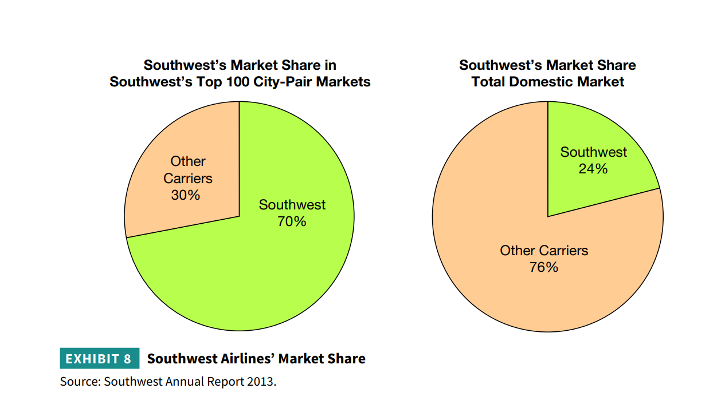

Southwest Airlines uses a risk reduction marketing strategy. The company ensures that it promises its customers what it is capable of offering. This makes customers not to have the wrong expectations. The airline promises low priced tickets and high-quality services. Southwest often under promises but over delivers on various services. The low price of tickets of Southwest Airlines has made customers associate the company with low prices. The airline uses ticketless travel to simplify its services. Although Southwest saved significant money on its operations, it was spending more than the average airline on marketing. In its first year of business, the airline spent 10 percent of its budget on advertising. The company had continued to emphasize marketing throughout its history, even increasing its marketing during difficult years. As Kelleher explained, “When do you need advertising the most? When times are bad.”15 When Southwest achieved record profits and load factors in 2010, CEO Gary Kelly credited the company’s highly successful “Bags Fly Free” ad campaign for the success.16 The campaign cost Southwest $159.5 million to produce, which was nearly the same as the combined advertising budgets of Delta, United, American, and Continental.

1. **What prevents larger competitors (e.g., American, Delta, United) from imitating Southwest’s approach?**

One fundamental reason that other airlines are not copying Southwest’s low-fare model is that they are not trying to offer low-priced tickets. Other companies have made the conscious decision to cater to a different type of customer. These companies have come to understand that while some people may want to fly for the lowest possible rate, a significant amount of other people would prefer to pay more for their air fare in order to enjoy more perks for the price. This case shows how Southwest’s “point to point” business model and the activities associated with that business model create cost advantages. The concept of “reinforcing fit” helps to explain as a reason for its success at lowering costs—as well as a reason it is difficult for competitors to imitate. In an Industry posing some of the highest fixed cost in the world maintaining a large fleet is a deterrent to keeping the cost low . It’s easier to fight the enemy you know than one you don’t. With gale-force winds of competition lashing every industry, companies must invest a lot of money, people, and time to fight archrivals. They find it tough, challenging, and yet strangely reassuring to take on familiar opponents, whose ambitions, strategies, weaknesses, and even strengths resemble their own. However, this obsession with traditional rivals has blinded companies to the threat from disruptive, low-cost competitors. Such companies offer products and services at prices dramatically lower than the prices established businesses charge, often by harnessing the forces of deregulation, globalization, and technological innovation, which the larger competitors cannot entertain. Successful price warriors stay ahead of bigger rivals by using several tactics: They focus on just one or a few consumer segments; they deliver the basic product or provide one benefit better than rivals do; and they back everyday low prices with superefficient operations to keep costs down.

1. **What prevents new entrants from successfully imitating Southwest’s approach?**

Southwest has received considerable publicity about its success. Over the years, a number of firms have tried to imitate Southwest's strategy, but they have been unsuccessful. While Southwest was a regional carrier, most major airlines largely ignored it (except those that had large market shares in the regions served by Southwest). However, Southwest has grown and is no longer a regional airline. In 1999, it initiated its first transcontinental flight. It is well known that Southwest has been able to create a successful strategy through strong leadership, a unique and favorable corporate culture, and excellent employees. These three largely tacit competencies make it difficult for competitors to imitate Southwest's strategy effectively. The other strategy the firm used was reducing the time taken in turning of its planes and getting them flying. According to Dyer et al. (2016) the American airlines’ average turn around period takes forty-five minutes. However, Southwest has reduced its planes’ turnaround time to twenty-three minutes. The reason is attributed to its high efficiency through point-to-point destinations, using only one type of aircrafts, and offering the basic services without frills. The result is minimization of time spent in either cleaning the planes after customer use or even their repairs. It thus becomes cumbersome for new entrants to adopt its strategy due to lack of enough capital to sustain the methods, while the existing large firms would end up making losses.

1. **How should Southwest should grow, given that fact that it has largely saturated its short-haul markets with point-to-point service? Should it expand into long haul and add a longer range aircraft?  Should it expand into international service?  If it does, how will this differ from its current strategy/business model and how will this influence performance?**

To expedite progressive growth of the airline, Southwest Airlines should venture into the long-haul routes and international markets. Although, in so doing, the airline would be venturing into markets that have other dominant airlines. For Southwest Airlines to expand into international markets effectively, it should form alliances with other companies. Alliances enable airlines to share airport facilities and integrate their services. Alliances are vital for profitability in international markets.

However, expansion into international markets may pose several challenges to Southwest Airlines. Entry into the international market necessitates the airline to use larger planes to ensure profitability. Southwest Airlines uses only Boeing 737 planes, which have a low capacity. Changing the type of aircraft may increase operational costs of the company. In addition, due to the long flight time of international flights, Southwest would have to introduce inflight entertainment. This would force the airline to increase ticket prices. These factors may change the image of the airline as a low-cost airline.

Southwest should pursue an expansion strategy through code sharing. Code sharing allows Southwest Airlines to share the routes of these airlines. This would reduce the need for the company to establish its brand to the new customers. Southwest Airlines may also use acquisition to venture into international markets. Very few low-cost airlines fly internationally. Therefore, there is limited competition in low-cost international flights.